**THE HIDDENSEE**

**Hiddensee** is a [car-free](https://en.wikipedia.org/wiki/Auto-free_zone) island in the [Baltic Sea](https://en.wikipedia.org/wiki/Baltic_Sea), located west of Germany's largest island, Rugen, on the [German](https://en.wikipedia.org/wiki/Germany) coast.

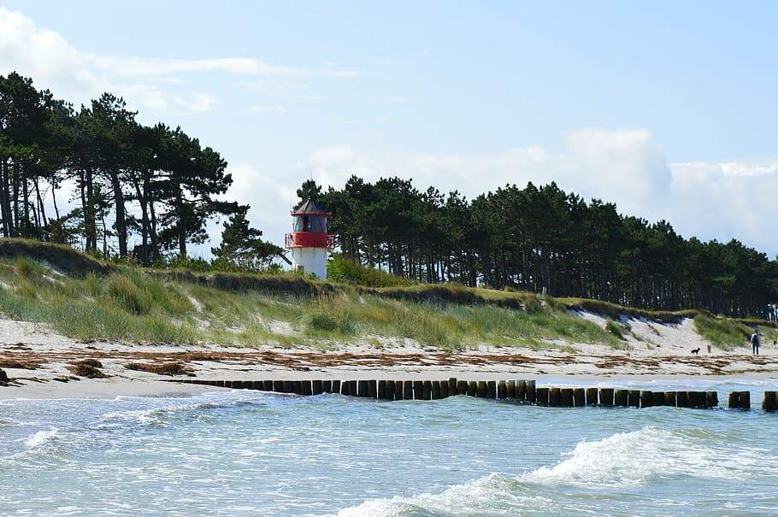The island has about 1,000 inhabitants. It was a holiday destination for [East German](https://en.wikipedia.org/wiki/East_Germany) tourists during [German Democratic Republic](https://en.wikipedia.org/wiki/German_Democratic_Republic) (GDR) times, and continues to attract tourists today. It is the location of the [University of Greifswald](https://en.wikipedia.org/wiki/University_of_Greifswald)'s